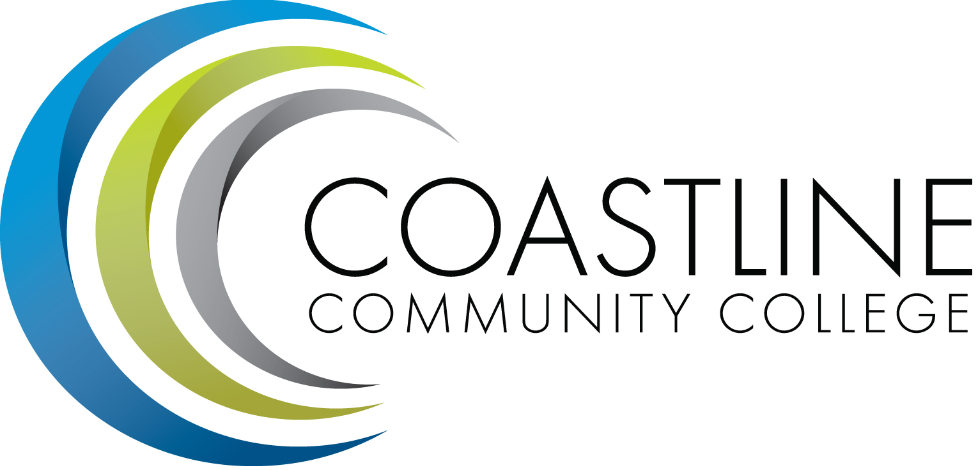

College Professional Development & Leadership Committee Agenda
5/02/2017
3:00 pm to 5:00 pm
College Center, Distance Learning Conference Room
Committee Mandate: To promote, coordinate, recommend, and support the creation and delivery of professional development and leadership programs that increase the effectiveness of our institution and the satisfaction of our employees.
- CALL TO ORDER
  - Roll Call
Present | Members
 | Bob Nash, Co-chair, Associate Dean, Distance Learning & Prof. Development
 | Cheryl Chapman, Co-chair, Academic Senate Representative
 | Renate Akins, Director of HR
 | Mitchell Alves, Faculty Success Center Coordinator
 | Judy Garvey, MECTBD Administrator Representative
ABS | Elaine Hill, Classified Senate Representative
 | Ken Leighton, Academic Senate Representative
 | Dorothy McCollom, Classified Senate Representative & Committee Support
 | Araba Mensah, Classified Senate Representative
 | Randall Warwick, Academic Senate Representative
Guest: Ann Holliday, Shelly Blair
  - Welcome
  - Adoption of Agenda
  - Approval of Minutes: 4/04/2017

- SPECIAL REPORTS & UPDATES
  - IEPI Report

- ACTION ITEMS
  - None

- STANDING REPORTS
  - Cornerstone Update – Renate & Crystal
  - Faculty Success Center (FSC) Update – Cheryl
  - Flex Coordinator Update - Ann

- DISCUSSION ITEMS
  - All College Spring Workshop Results
  - Summer Institute (July 13 & 14, 2017) Update – Bob
  - Fund @One Course, “Creating Accessible Course Content” ($65 per person)
  - Renewal of Innovative Educators (last year we paid $2,396)
  - Renewal of Online Learning Consortium Institutional Membership ($1,495)
  - California Community College Council Membership ($175)
  - Summarize Key Accomplishments and Identify Goals
  - End-of-Year Survey for College Professional Development & Leadership Committee Members

- ANNOUNCEMENTS (1-2 minutes per)
  - Online Learning Consortium Call for Submissions for Digital Learning Innovation Award (Open Until June 30, 2017)
  - Next Meeting, September 5, 2017 at 3:00 pm

- ADJOURNMENT

